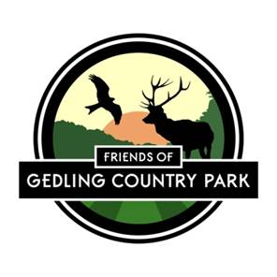 | Friends of Gedling Country Park

NOMINATION FORM FOR THE MANAGEMENT COMMITTEE OF FRIENDS OF GEDLING COUNTRY PARK

If you would like to become a Trustee of the Friends of Gedling Country Park or would like to nominate any willing member, would you please complete this nomination form and return it to Terry Lock, 6 Shearing Hill, Gedling, Nottingham NG4 3HA before Monday
25th January 2016 or at the AGM.

I nominate....................................................................................................... Name

To serve as a Trustee on the Management Committee of Friends of Gedling Country Park

Nominator...................................................................................................... Name

Seconded by................................................................................................. Name

I accept to serve as a Trustee on the Management Committee of Friends of Gedling Country Park, if elected at the Annual General Meeting.

Candidate................................................................................................... Signature

